**DATE**: Thursday, December 12, 2024

**TO**: Conservatives for Clean Energy--Louisiana

**FROM**: Brock McCleary, Vice President

**RE**: Louisiana Statewide Poll of Republicans and Independents on Energy

***Methodology****: This probabilistic survey was conducted November 17 - 19, 2024, with 600 Louisiana voters who are registered as a Republican or Independent. It has a margin of error of ±3.92%. Voters were interviewed via live phones and SMS. This survey was weighted to ensure a representative sample.*

***America Needs More Energy Independence***

* 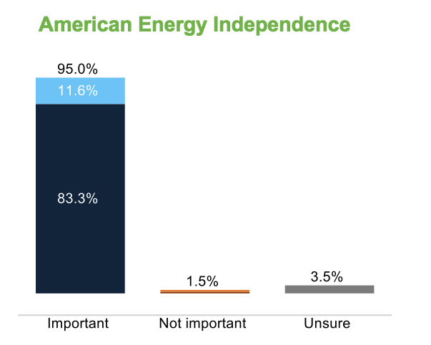There is near universal belief among Republicans and Independents that **American energy independence is of high importance**.

*How important do you believe it is that the United States ensure American energy independence, producing sufficient domestic energy to power the nation’s economy and protect it from global supply disruptions and price spikes?*

* Voters over 55 years of age place higher importance on energy independence.
* 91% of **those who voted for Donald Trump in 2024** say energy independence **is *very* important**.
* Energy independence is important across all geographies in the state.
* A majority of Republican and Independent voters agree that **Louisiana should pursue an all-of-the-above energy strategy** (60%).
* The same number of voters *strongly* agree (31%) with an all-of-the-above energy approach as *all* voters who disagree (31%).
* 52% of Trump voters agree.
* *A graph showing a number of electricity rates

  Description automatically generated*A majority of voters across **all state media markets** support an all-of-the-above energy strategy for Louisiana with support highest in Baton Rouge (63%) and lowest in Lafayette/Lake Charles (54%).
* Voters report **electricity rates** to be highest in the New Orleans market and lowest in Lafayette/Lake Charles markets.

***Energy Made in Louisiana Similarly Popular to Energy Independence***

* 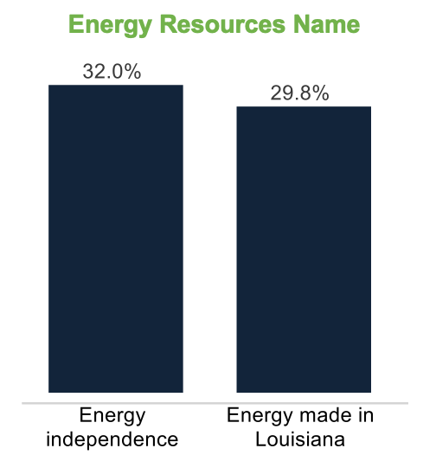Voters believe energy independence and energy made in Louisiana are top terms to describe strengthening energy resources.
* Energy independence and Louisiana-made energy are key terms for messaging on all-of-the-above energy production.

*When it comes to the future of energy in Louisiana, which of the following terms do you think best represents a focus on strengthening our energy resources?*

***Strong popularity for President Trump & Governor Landry***

* ***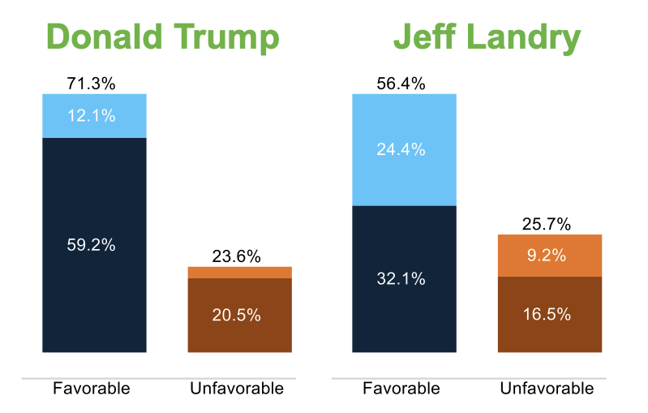*Donald Trump’s image** is strongest in Lafayette/Lake Charles (80% favorable, 18% unfavorable) and weakest in the New Orleans media market (62% favorable, 30% unfavorable).
* **Governor Landry’s image** is strong and comparable to his job approval at 57% approve, 28% disapprove.
* The **Governor’s job approval** is also strong with **Republicans** at 72% *approve*, 14% *disapprove*.

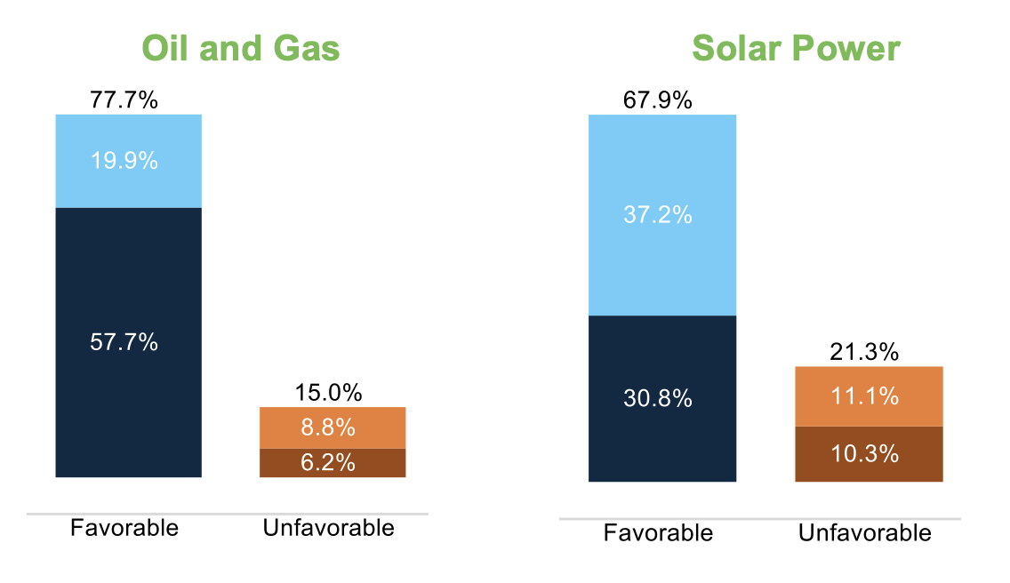***Oil and Gas Most Popular, But Solar Keeps Pace***

* Voters favor **oil and gas** (78% favorable, 15% unfavorable) the highest of the energy sources tested. **Solar power** (68-21%) rates the second highest. **Wind power** rates lower but a near majority have a favorable opinion (49-34%) while **offshore wind** generates more uncertainty (39-26%), but still is viewed more favorable than unfavorably.
* **Wind power** is more popular in the **New Orleans market** (56% favorable, 28% unfavorable) and with women (51-26%) and **offshore wind** gets a boost in the **Baton Rouge market** (41-32%).
* **Solar power** is most popular in the **New Orleans market** (74% favorable, 14% unfavorable) and in the **Shreveport market** (70-21%), but a strong majority in other areas of the state still have a favorable opinion of it.
* **Trump voters** strongly back **solar power** (63% favorable, 26% unfavorable).
* **Carbon capture** (28% favorable, 20% unfavorable) and **clean hydrogen** (48-9%) have the highest portions of those saying they have never heard of it at 31% and 22% respectively and one-in-five voters say they have **no opinion** on either of them.
* Clean hydrogen is most favorable in the **Baton Rouge market (63%)**.

***Voters Want More Emphasis on Oil, Gas, and Solar***

*Please indicate if you believe Louisiana should place more emphasis, less emphasis, or about the same emphasis as it does now on producing domestic energy from the following sources...*

a5d9af9b-f05c-48dc-ab50-e7f6dd5798a1 Domestic Energy Sources

* Republican and Independent voters want to see the most **increased emphasis with natural gas** (62%) while there is strong support for **oil** (55%) and **solar** (49%). More voters prefer to see a greater emphasis on **wind power** than those who prefer less emphasis.
* More emphasis on solar is popular in the **New Orleans market** (54%), while nuclear and solar are equally popular in the **Baton Rouge market** (47%). Similarly, the **Lafayette market** wants more solar (42%) and nearly half in the **Shreveport market** (49%) want the same.
* Voters become more favorable toward wind power when asked about **offshore wind options**, with 52% **favoring the development** of it.
* Support for the development of **carbon capture** and **clean hydrogen** increases when voters **learn more about it**.

*Do you favor or oppose the development and use of clean hydrogen as an energy source, which produces fewer emissions and can be used in industries like transportation and manufacturing?*

*Do you favor or oppose the use of carbon capture technology, which captures carbon emissions from industrial sources and safely stores it in a way that is unable to affect the atmosphere with the aim of reducing pollution?*

***Louisiana Plays A Critical Role in Securing the Grid***

|  |  |  |
| --- | --- | --- |
| ***Top Messages*** | ***More Likely*** | ***Much More Likely*** |
| ***Russia & China: Expanding renewable energy sources reduces reliance on foreign energy and strengthens our energy independence. With more U.S. based energy, we can better defend ourselves against global energy manipulation from countries like Russia and China.*** | ***76%*** | ***53%*** |
| ***Grid Security: Renewable energy can make our power grid stronger, providing backup power sources in emergencies. A strong grid means fewer outages and better protection against cyber and physical threats.*** | ***74%*** | ***46%*** |
| ***Good Jobs: Accelerating the growth of cleaner energy in Louisiana would position our state to be a national leader in the competition for economic development and good paying jobs.*** | ***74%*** | ***43%*** |
| ***Landry Reform: Governor Jeff Landry is leading efforts to enact permitting reform in Louisiana to advance renewable energy projects.*** | ***55%*** | ***19%*** |
| ***Drive Innovation: Louisiana companies investing more in cleaner energy sources would give businesses and consumers more choices than traditional oil and gas fuels in order to drive innovation and competitive pricing.*** | ***63%*** | ***31%*** |
| ***Trump CCS: President Trump has been a leader in promoting carbon capture and storage technology to reduce harmful emissions. Trump recognizes that technology will drive the solutions to America’s energy needs while strengthening our economy and reducing pollution.*** | ***63%*** | ***18%*** |

* Messages regarding American **energy grid security**, energy independence in the face of **competition from Russia & China**, and energy expansion **creating good jobs** hit home among survey participants. Support for an all-of-the-above energy strategy grows to 67% after messaging.
* The *Russia & China* message elicits the most voters saying they would be *much* more likelyto support the development of clean energy.
* **Republicans** are most persuaded by the *Drive Innovation* message. **Very conservative** voters are most moved by the ***Trump CCS***message while **somewhat conservative** voters are most moved by *Russia & China*.

*Do you agree or disagree with the following statement: Louisiana should pursue an all-of-the-above energy strategy, which means lowering our heavy dependence on fossil fuels over time and allowing an increase in electricity generation from emerging technologies like renewable energy?*

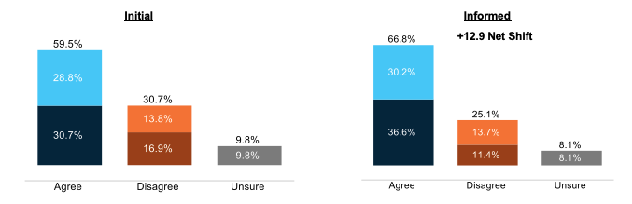

***Louisiana Voters Want Greater Consumer Choice in Energy. Clean Energy That Makes Sense for Louisiana Will Create More Energy Choices for Customers, Not Eliminate Them***

* A graph of a bar chart

  Description automatically generated with medium confidenceLouisiana voters see the need for greater energy choice, which creates jobs and strengthens our economy in the long run. Two-thirds of voters clearly support increasing consumer choice in energy (81%) and would like to see bureaucratic red tape cut (69%).

*Do you agree or disagree that Louisiana should minimize bureaucratic red tape and regulations that make it more difficult to generate electricity using wind, solar, and other renewable energy sources?*

*Do you support or oppose policies that increase consumer energy choice, allowing individuals and businesses more options to select their energy sources, such as renewable energy, natural gas, or traditional fuels?*

***An All-Of-The-Above Energy Strategy Will Drive Innovation, Create Jobs and Help Lower Costs***

* Nearly 7-in-10 of both **Republicans (69% agree) and Independents (68%)** favor cutting bureaucratic red tape and regulations that hinder the generation of electricity through renewable sources.
* **Voters clearly support replacing transmission wires** (81% support) and the **development of new lines** (70% support).
* Support for new lines is strongest in the **New Orleans** (71%) and **Batton Rouge** (73%) markets, while at least two thirds support it elsewhere.

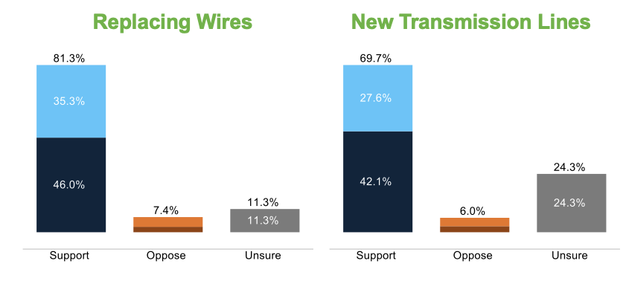

*Do you support or oppose the development of new electric transmission lines?*

*Where it makes sense, do you support or oppose replacing old transmission wires with new wires that may cost a bit more but could triple the amount of energy that can be delivered?*